MNIST Digit Recognition – OCTAVE

**~KARTHIK KARUMANCHI**

**Neural Network Implementation**

**Architecture :**

Output Layer (10 Units)

Hidden Layer1 (50 units)

Hidden Layer2 (50 units)

Input Layer (784 Units)

**Optimising Algorithm** : ***fmincg***

**Random Initialisation** : theta C [ -epsilon,epsilon] where epsilon = 0.2

**Regularisation Parameter:** l = 15.0

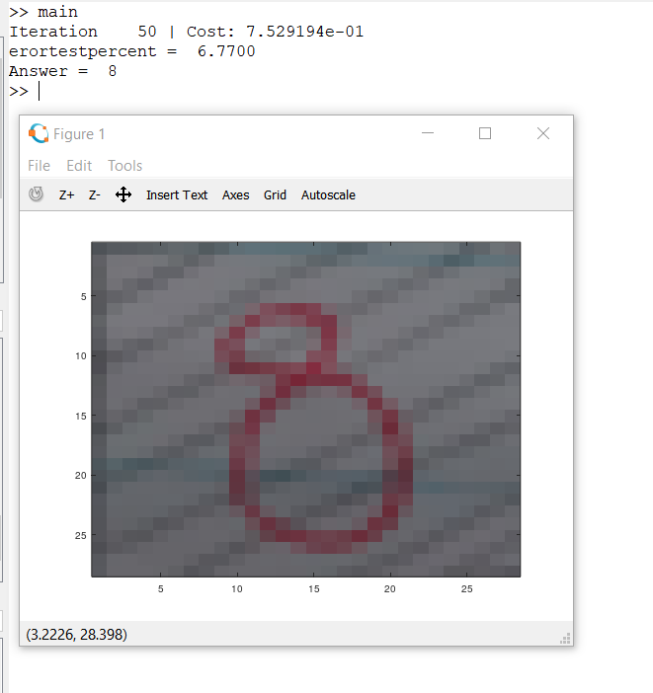

Final Output with the input as given below